INFOSYS SPRINGBOARD INTERNSHIP 7.0
SUPPLY CHAIN VISIBILITY & OPTIMIZATION
MILESTONE 2 – PROJECT REPORT
Domain: Data Visualization
Prepared by: Pochuru Supraja

1. Introduction
Supply Chain Visibility & Optimization is a data analytics project focused on improving the visibility and performance of supply chain operations. The project analyzes information related to products, inventory, sales, suppliers, logistics, transportation, inspection and fulfillment. Python was used for data preprocessing and exploratory analysis, while Power BI was used to develop interactive dashboards for business decision-making.
Milestone 2 focuses on converting the cleaned supply-chain dataset into meaningful KPIs, analytical visualizations and actionable business insights.

2. Objectives of Milestone 2
- Perform Exploratory Data Analysis (EDA) on the processed dataset.
- Identify important supply-chain performance indicators.
- Create DAX measures for KPI calculations.
- Develop interactive Power BI dashboards.
- Analyze inventory, revenue, fulfillment and logistics performance.
- Compare product and supplier performance.
- Analyze transportation and inspection results.
- Generate actionable recommendations for supply-chain optimization.

3. Dataset Overview
The dataset used for the project contains:
- 1,540 records
- 24 attributes
- Product information
- Inventory and sales information
- Revenue and logistics information
- Supplier and manufacturing information
- Inspection results and defect rates
The major data areas include product type, SKU, price, availability, quantity sold, revenue, shipping time, carrier, transportation mode, route, supplier and quality-related information.

4. Exploratory Data Analysis (EDA)
Exploratory Data Analysis was performed to understand the structure, quality, patterns and relationships within the supply-chain dataset.
The EDA process followed:
Data Understanding → Quality Check → Analysis → Visualization → Insights
- Inventory performance
- Product performance
- Supplier contribution
- Revenue patterns
- Logistics performance
- Fulfillment performance
- Transportation modes
- Inspection results
- Defect rates
EDA helped identify important business questions that were later converted into Power BI KPIs and visualizations.

5. KPI Analysis and DAX Measures
DAX measures were created in Power BI to calculate important supply-chain KPIs.
KPI | Purpose
Total Orders | Measures overall order volume
Total Inventory | Measures available inventory
Inventory Value | Measures value of remaining stock
Inventory Turnover | Measures inventory efficiency
Fulfillment Rate | Measures shipment effectiveness
Average Shipping Time | Measures logistics performance
Average Delivery Time | Measures delivery performance
On-Time Delivery Rate | Measures service reliability
DAX measures provide consistent, reusable calculations that respond to filters and visual context in Power BI.

6. Power BI Dashboard 1 – Inventory & Data Analytics
The first dashboard provides an overall view of supply-chain inventory and operational performance.

6.1 Key KPI Values
KPI | Value
Total Inventory | 75.62K
Inventory Value | 3.75M
Inventory Turnover | 9.39
Fast-Moving Products | 768
Slow-Moving Products | 767
Total Revenue | 8.84M
Average Shipping Time | 5.74 days
Average Delivery Time | 5.74 days
Total Orders | 2K
Fulfillment Rate | 90.38%

6.2 Dashboard Visualizations
- Total Inventory by Product Type
- Revenue Generated by Product Type
- Fulfillment Rate by Transportation Mode
- Total Inventory by Location
- Stock Levels by SKU
- Average Shipping Time and Delivery Time by SKU
- Interactive filters for product type, inspection results, supplier, location, route, shipping carrier and transportation mode
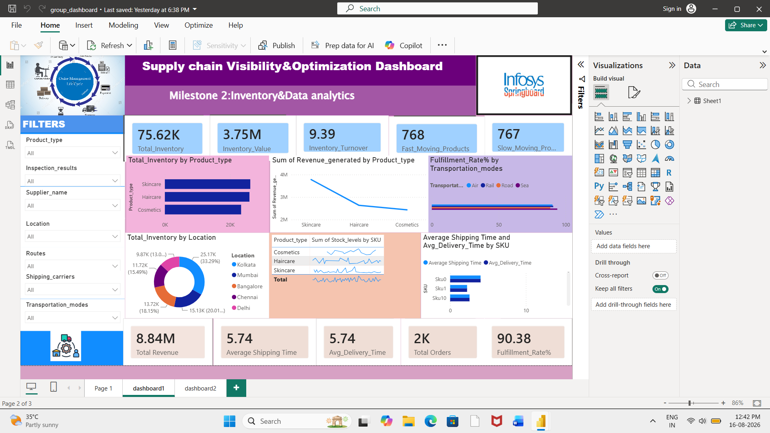

7. Power BI Dashboard 2 – Product & Supplier Analysis
The second dashboard provides detailed analysis of products, suppliers, quality and transportation.

7.1 Fast-Moving Products by Location
Fast-moving products are compared across Kolkata, Mumbai, Bangalore, Chennai and Delhi to understand geographical demand patterns.

7.2 Inventory Value by Supplier
Supplier-level inventory value is compared to understand supplier contribution. Supplier 1 has the highest inventory value contribution, which may require closer monitoring because higher supplier concentration can create dependency risk.

7.3 Total Orders by Inspection Results
Inspection results are divided into Pending, Pass and Fail. Pending inspections account for approximately 45.15%, highlighting a need to improve inspection processing.

7.4 Defect Rate by Product Type
Defect rates are compared across Skincare, Haircare and Cosmetics. Cosmetics show higher defect-rate values and therefore require additional quality attention.

7.5 Inventory by Transportation Mode
Inventory is analyzed across Road, Rail, Air and Sea. Road transportation has the largest inventory share at approximately 41.37%.

7.6 Supplier Product Sales
The dashboard compares the number of products sold by different suppliers, allowing supplier performance to be evaluated alongside inventory contribution.

7.7 Detailed SKU Table
- SKU
- Product type
- Price
- Number of products sold
- Revenue generated
- Stock level

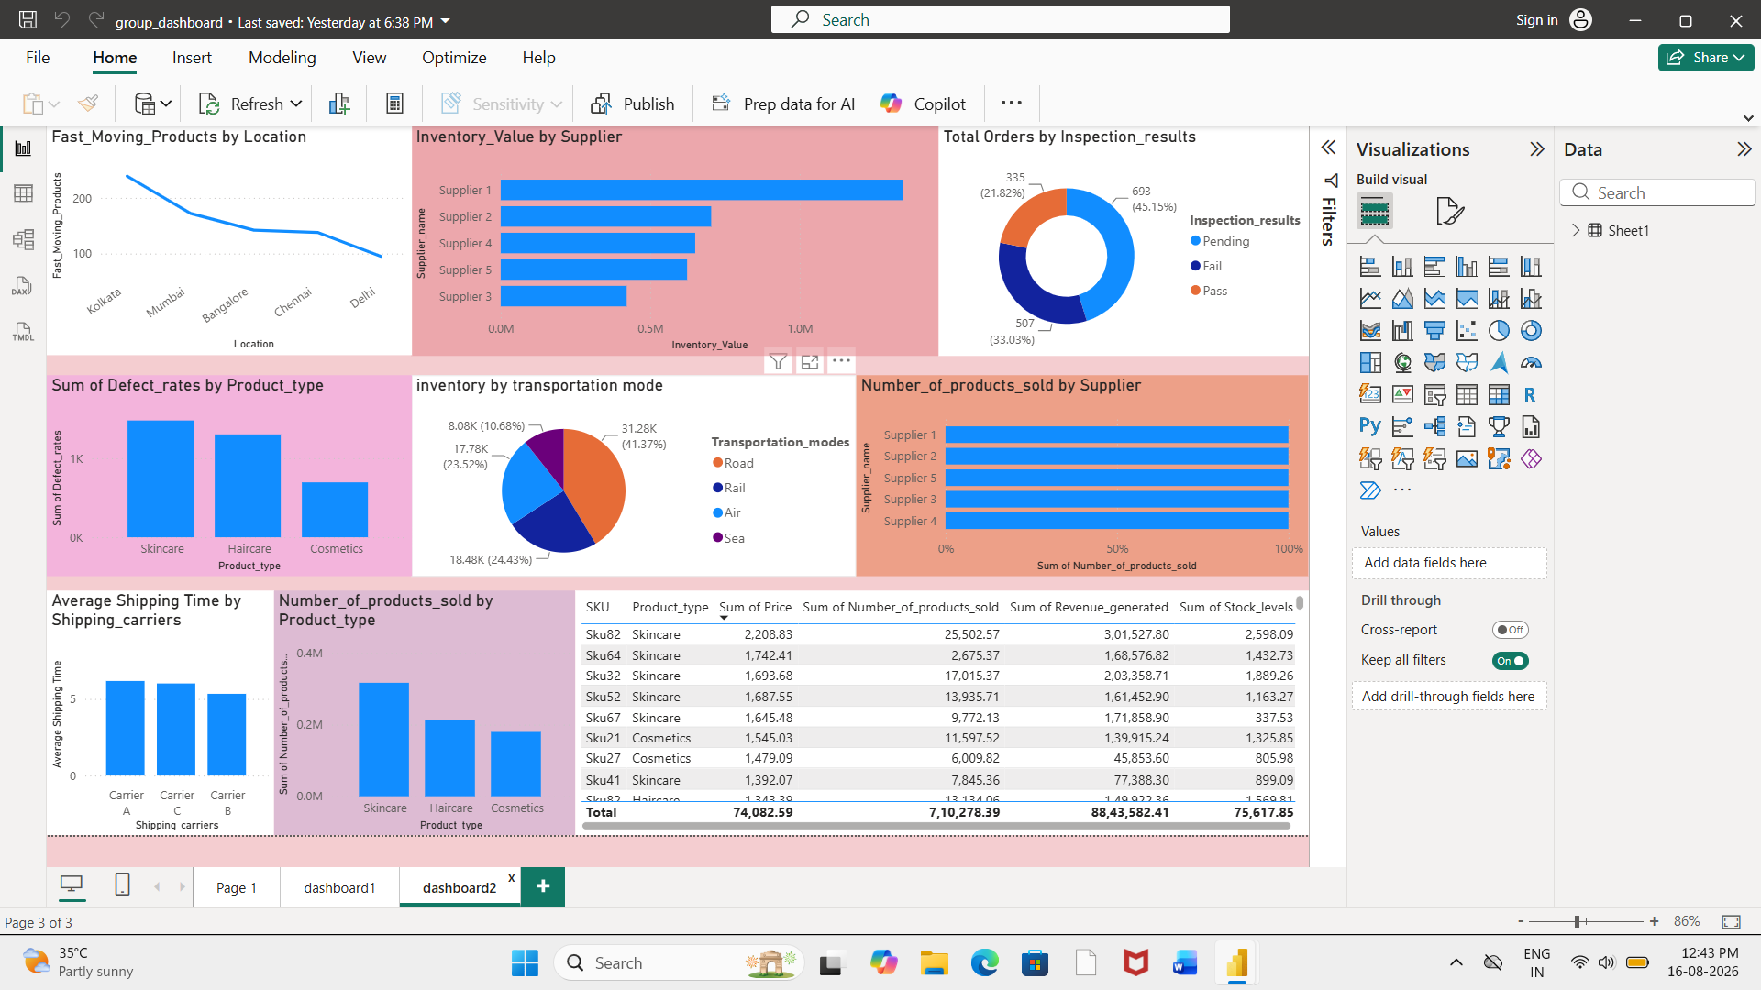

8. Key Findings

8.1 Inventory Performance
Total inventory is approximately 75.62K, with an inventory value of approximately 3.75M. Inventory turnover is 9.39. Fast-moving products and slow-moving products are almost balanced, with 768 fast-moving and 767 slow-moving products.

8.2 Product Performance
Skincare contributes strongly to inventory and revenue performance. Haircare shows steady sales performance, while Cosmetics require additional attention because of their relatively higher defect rates.

8.3 Supplier Performance
Supplier 1 contributes the highest inventory value. Supplier-level monitoring is important to identify supplier dependency and potential disruption risks.

8.4 Logistics Performance
The average shipping time is 5.74 days and the average delivery time is 5.74 days. The fulfillment rate is 90.38%, indicating strong overall order fulfillment performance. Road transportation handles the largest inventory share at 41.37%.

8.5 Quality Performance
Approximately 45.15% of inspections are pending, indicating a need for faster inspection processing. Cosmetics show higher defect-rate values compared with the other product categories.

9. Recommendations
- Regularly monitor inventory levels and inventory value to reduce shortage and excess-stock risks.
- Use fast-moving and slow-moving product analysis to improve replenishment and stock distribution.
- Investigate the causes of higher defect rates in Cosmetics and strengthen quality-control procedures.
- Improve inspection processing to reduce the high percentage of pending inspections.
- Closely review suppliers with high inventory contributions, especially Supplier 1.
- Analyze transportation modes, carriers and locations to identify opportunities for cost and delivery-time optimization.
- Continue monitoring fulfillment rate, shipping time and delivery time to maintain service performance.
- Introduce KPI thresholds and trend alerts in future dashboard versions.

10. Business Impact
The Milestone 2 dashboard converts raw supply-chain information into a decision-support system.
- Monitor inventory levels
- Track inventory value
- Identify fast- and slow-moving products
- Compare supplier performance
- Analyze product quality
- Monitor fulfillment
- Evaluate transportation modes
- Identify logistics issues
- Examine revenue contribution
- Analyze SKU-level information

11. Future Scope
- Demand forecasting using predictive analytics
- Machine-learning-based supplier risk assessment
- Automated real-time reporting
- Stock shortage prediction
- Excess inventory prediction
- Automated KPI threshold alerts
- Advanced transportation optimization

12. Conclusion
Milestone 2 successfully transformed the processed supply-chain dataset into meaningful analytical insights using Python, DAX and Power BI. EDA provided an understanding of the data and identified important patterns. DAX measures converted business requirements into reusable KPIs, while Power BI dashboards presented inventory, product, supplier, quality, revenue and logistics performance in an interactive format.
The analysis shows a 90.38% fulfillment rate, 75.62K total inventory, 3.75M inventory value, 8.84M total revenue and 5.74 days average shipping time. The dashboards also highlight areas requiring attention, including pending inspections, Cosmetics defect rates, supplier dependency and transportation optimization.
Overall, Milestone 2 provides a practical foundation for data-driven supply-chain visibility, performance monitoring and optimization.

13. Tools Used
- Python – Data import, preprocessing, cleaning and EDA
- Power BI – Dashboard development, visualization, interactive filtering and KPI analysis
- DAX – Reusable KPI calculations and business measures

14. Milestone 2 Outcome
Raw Data → Data Preprocessing → EDA → KPI Questions → DAX Measures → Power BI Dashboards → Business Insights → Recommendations

